Apache is an open source web server software created and maintained by Apache software foundation. Since it an open source so it is free to use. It is a web server used for one or more HTTP based websites. It is widely used by web hosting companies to provide shared and virtual hosting.

**Steps to install the Apache server:**

* **Make Superuser:** Open terminal and use following command to make yourself superuser.  
  sudo su  
  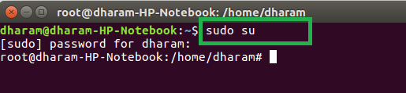
* **Update Ubuntu package:** Use the following command to update the Ubuntu package list.  
  sudo apt update  
  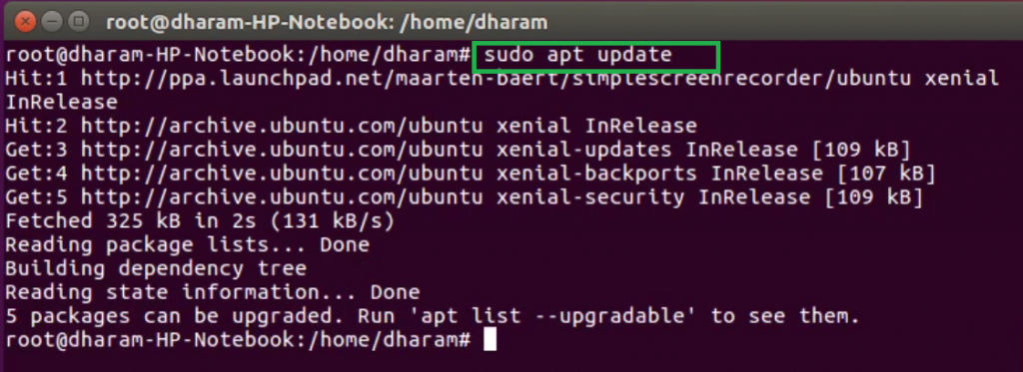
* **Install Apache:** After installing the Ubuntu package list, use the following command to install apache server.  
  sudo apt install apache2  
  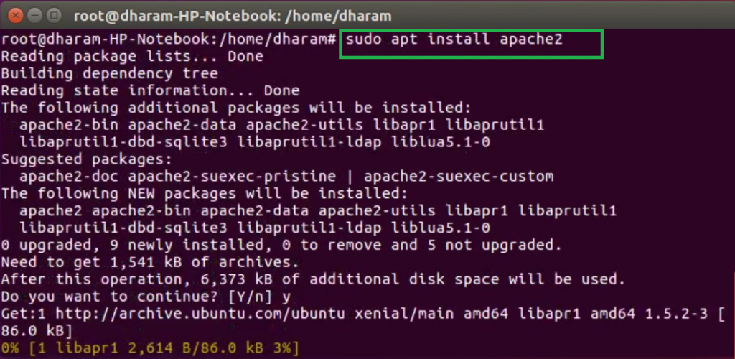
* After completion of the installation process, the Apache server automatically start. The status of the Apache server can be checked by using the following command.  
  sudo systemctl status apache2  
  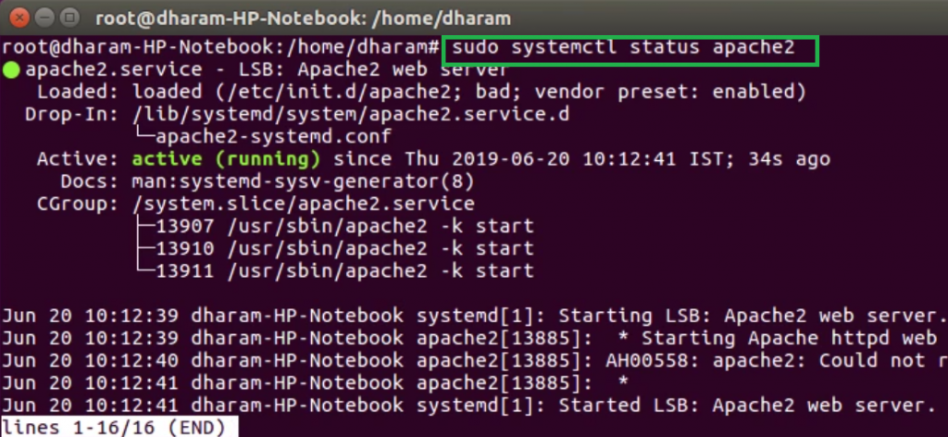
* Open the browser and type localhost or 127.0.0.1 on the address bar. It will display the default page of the Apache server.  
  